**Storing the state file in s3 bucket**

Store the tfstate in remote( s3) instead of local

Add backend in provider file

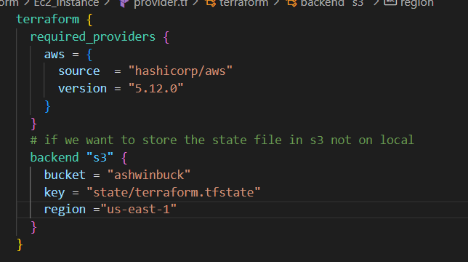

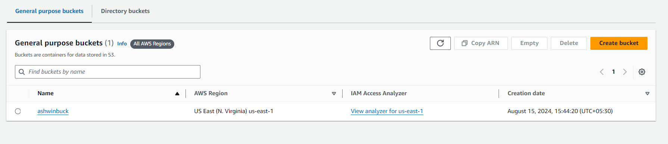

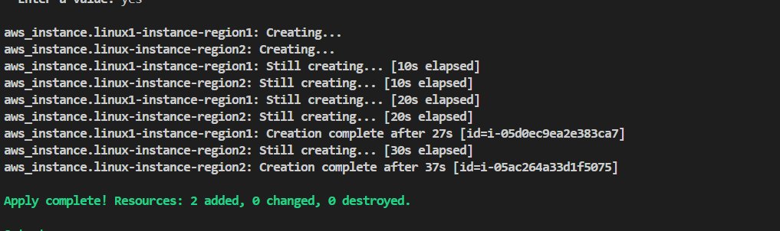

State file is not visible in local

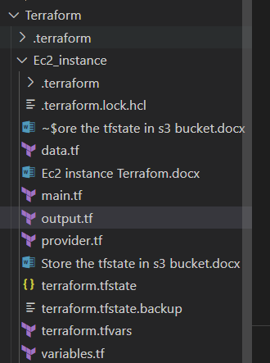

Instead it is visible in bucket

